**Set up the multimode Kubernetes cluster by using KOPS :**

* First create ec2 instance and update the server.
* Install the docker and Kubectl on that serverby using below command

**sudo curl -LO** [**https://dl.k8s.io/release/$(curl -L -s https://dl.k8s.io/release/stable.txt)/bin/linux/amd64/kubectl**](https://dl.k8s.io/release/$(curl%20-L%20-s%20https://dl.k8s.io/release/stable.txt)/bin/linux/amd64/kubectl)

* Give the execute permissions to kubectl file.
* Create the IAM user and add the administrator access policy and generate accesskey and scret key.
* Configure the AWS CLI by using **aws configure** command.If aws cli is not available we need to install by using **snap info aws-cli** command.
* Install the kops packages by using the below command.

**curl -LO** [**https://github.com/kubernetes/kops/release/download/v1.25.0/kops-linux-amd64**](https://github.com/kubernetes/kops/release/download/v1.25.0/kops-linux-amd64)

* Give the execute permissions to the kops-linux-amd64 file.
* Move the kops-linux-amd64 file to usr/local/bin/kops path by using below command

**mv kops-linux-amd64 /usr/local/bin/kops**

* Execute **ll** command open the .bashrc file by using **vi** command and add the export path like below

export PATH=$PATH:/usr/local/bin

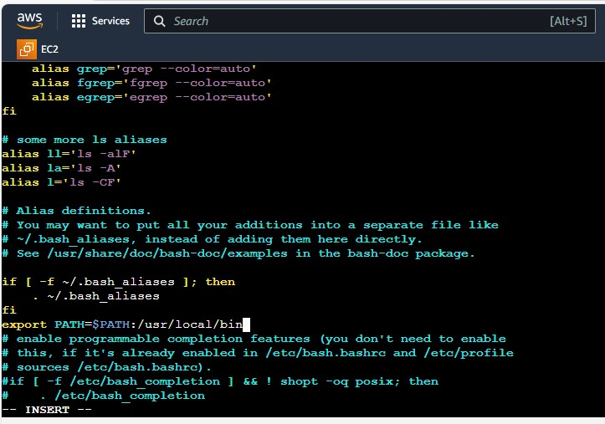

* Create the s3 bucket by using below command

**aws s3api create-bucket --bucket bucketname --region us-east-1**

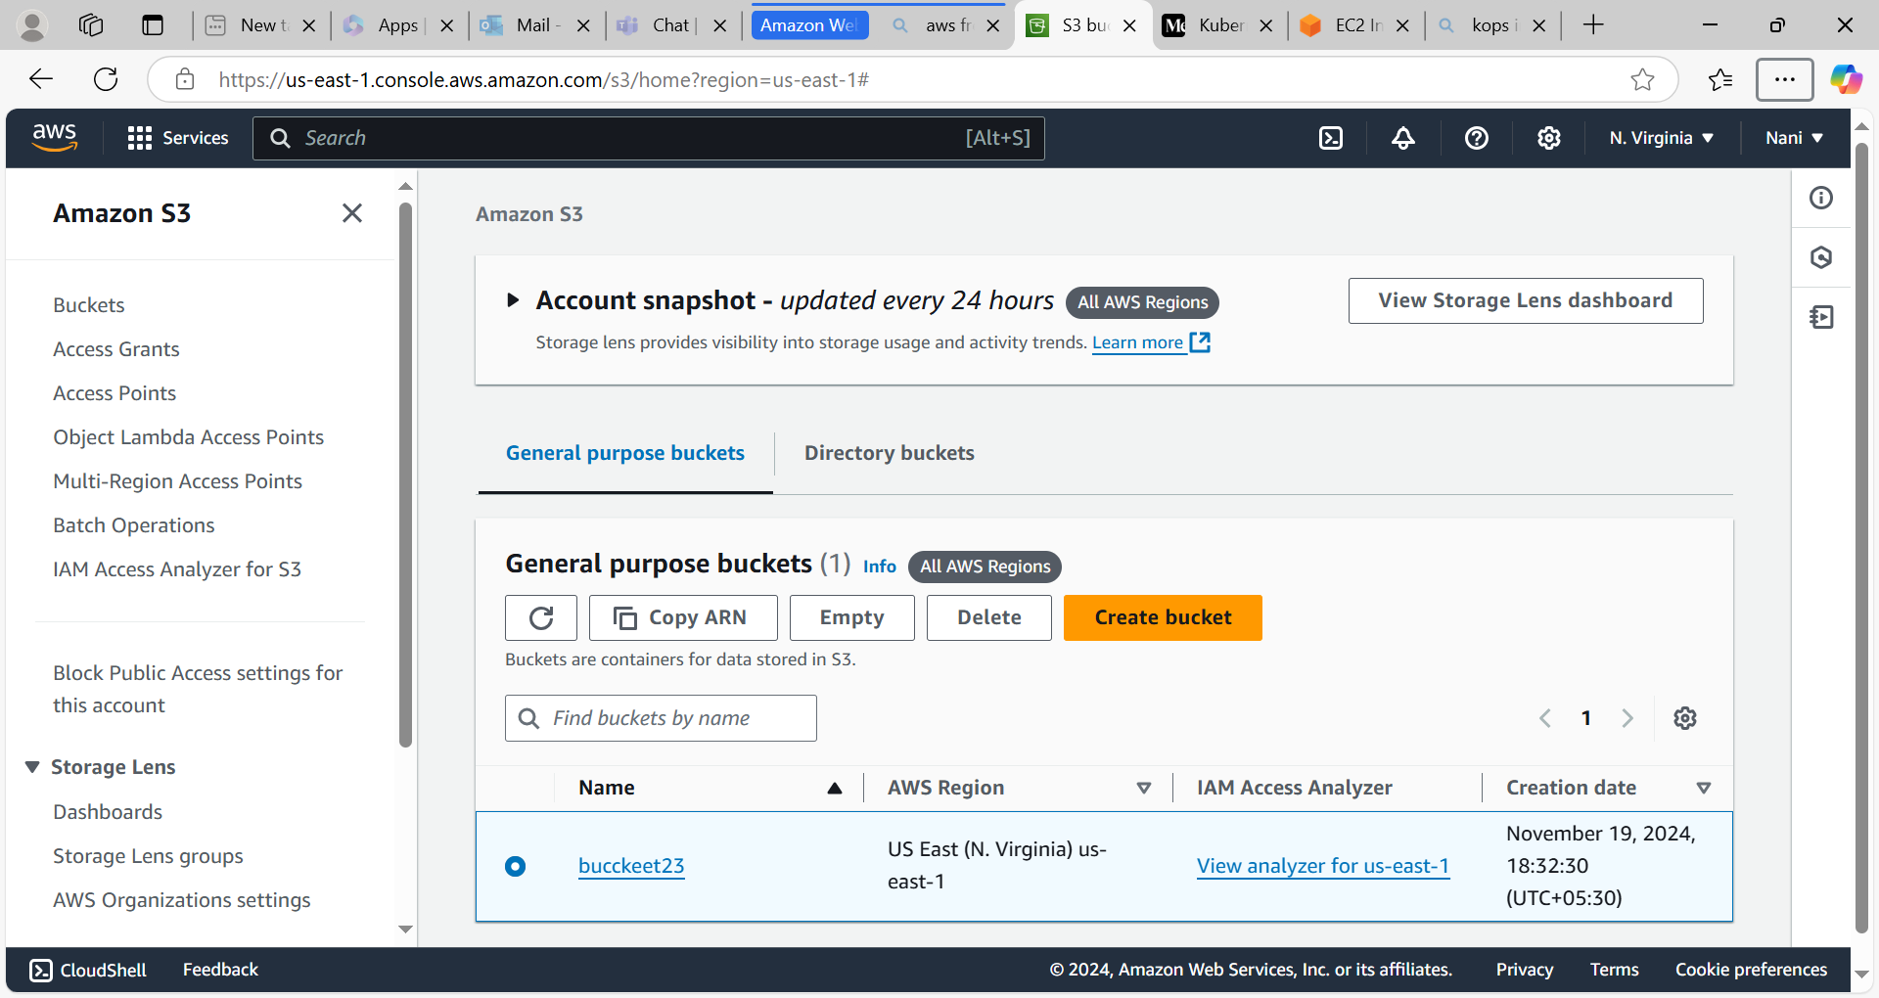

* Enable the s3 versioning by using below command

**aws s3api put-bucket-versioning --bucket bucketname --versioning-configuration Status=Enabled**

* Execute this below command

**export kops_state_store=s3://bucckeet23**

* Create the cluster by using below command

**kops create cluster --name name of the cluster --state=s3://bucketname --zones us-east-1a --master-size t2.medium --node-size t2.micro**

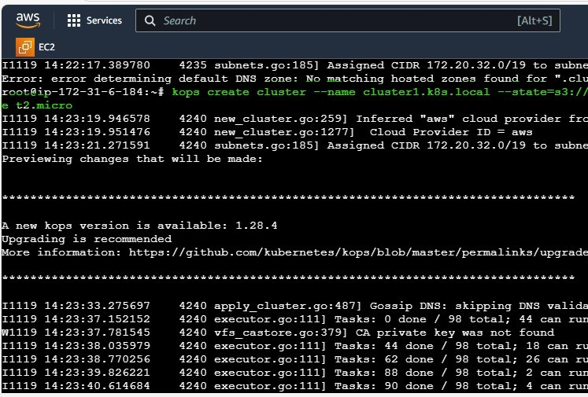

* After that execute below command to see the cluster information

**kops get clusters –state=s3://bucketname**

* Finally to configure the cluster by using below command

**kops update cluster --name clustername --yes --admin --state=s3://bucketname**

* Master and worker node is created on AWS

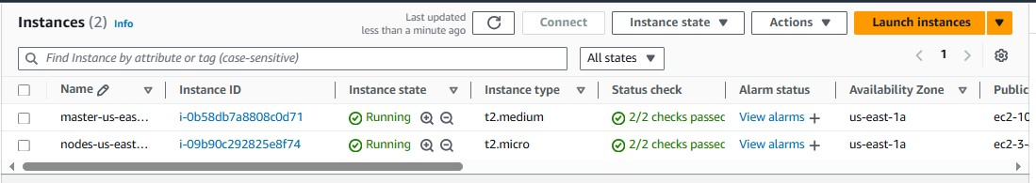

* Create the Autoscaling group

